Ideation Phase
Brainstorm & Idea Prioritization Template

Date | 30 September 2026
Team ID | MKU201Team56ab4dc836f290be8a6b49be8
Project Name | Import Data Using Transform Maps (ServiceNow Micro Project)
Maximum Marks | 4 Marks

Brainstorm & Idea Prioritization Template:
Brainstorming provides a free and open environment that encourages everyone within a team to participate in the creative thinking process that leads to problem solving. Prioritizing volume over value, out-of-the-box ideas are welcome and built upon, and all participants are encouraged to collaborate, helping each other develop a rich amount of creative solutions.
Use this template in your own brainstorming sessions so your team can unleash their imagination and start shaping concepts even if you're not sitting in the same room.
Reference: https://www.mural.co/templates/brainstorm-and-idea-prioritization
Step-1: Team Gathering, Collaboration and Select the Problem Statement

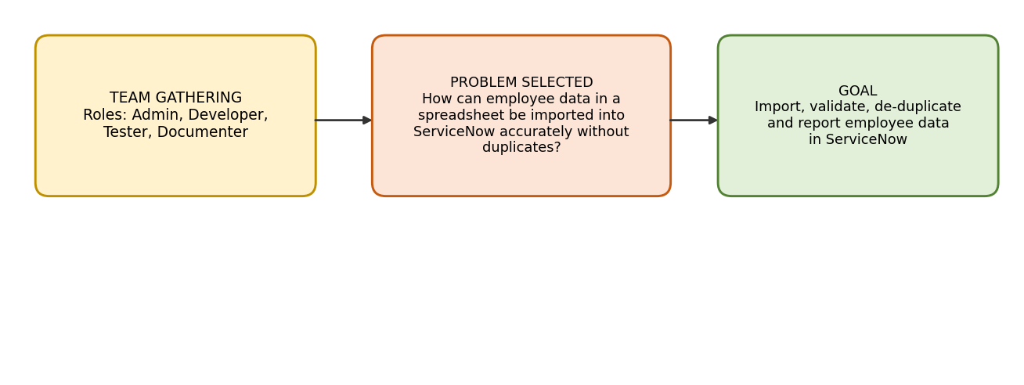
Team gathering and selected problem statement

Step-2: Brainstorm, Idea Listing and Grouping

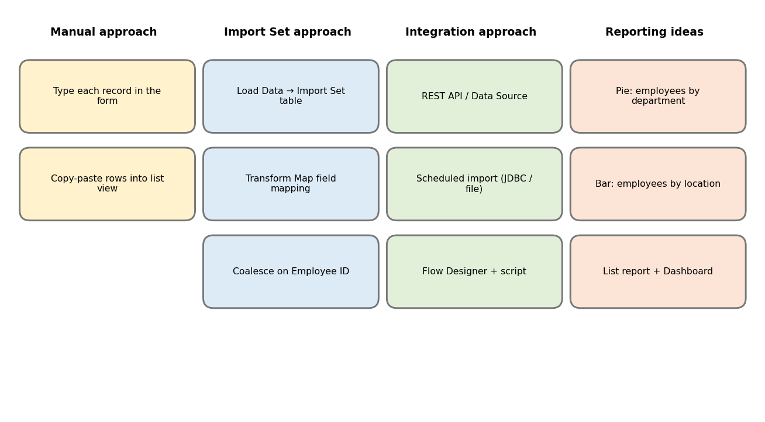
Ideas listed and grouped

Step-3: Idea Prioritization

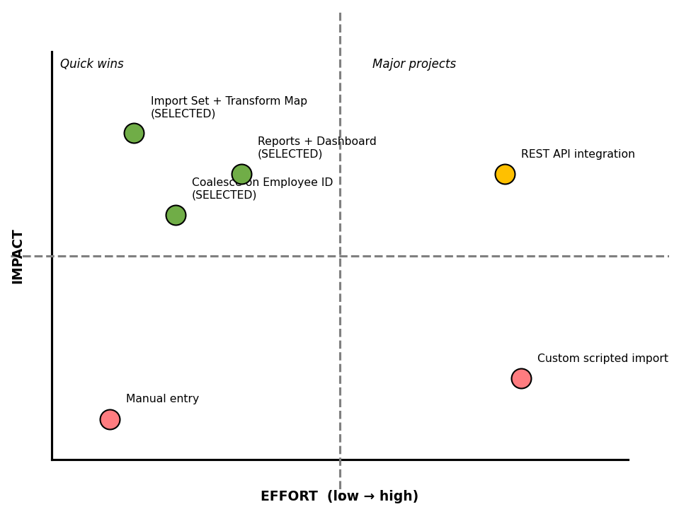
Idea prioritization (impact vs effort)

